**Lab 9 – Images in MATLAB**

**Exercise**

**Exercise 1**

**Apply filter to the salt & pepper image using MATLAB Commands.**

**Code:**

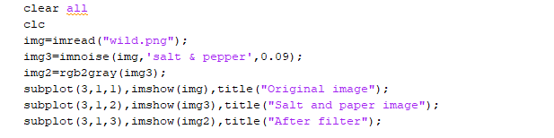

**Output:**

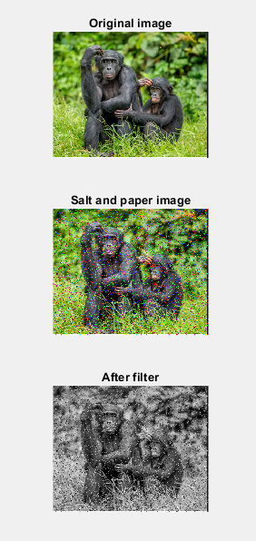

**Exercise 2**

**Add Gaussian noise on grayscale image using MATLAB Commands.**

**Code:**

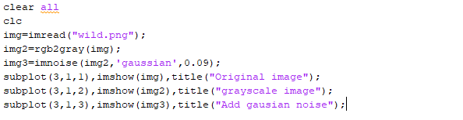

**Output:**

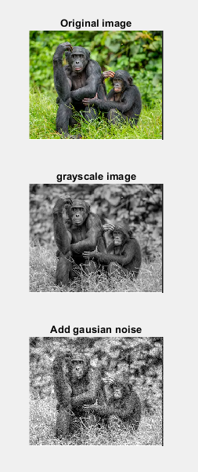

**Exercise 3**

**Apply filter to the Gaussian image using MATLAB Commands.**

**Code:**

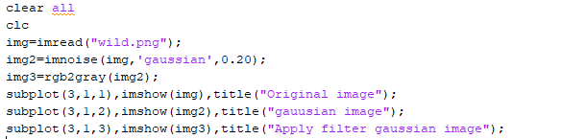

**Output:**

